KE28 -

Functionality
In Profitability Analysis: sales revenues, sales deductions and costs of goods manufactured are generally stored at the customer/product level. However, many business transactions - such as freight invoices, insurance expenses, or advertising - cannot easily be assigned to such a detailed level in CO-PA. Consequently, these need to be posted at a summarized level, such as the division, sales organization, or company code level.

Top-down distribution of actual data is a periodic function that lets you distribute this aggregated data to more detailed levels in CO-PA on the basis of reference information (such as the data from the previous year).

Scenario
Distribute Custom Clearance posted to Company Code/Product/Plant to Customer/Country.

Requirements
You use costing based Profitability Analysis.

Menu Path | Accounting → Treasury → Profitability Analysis → Actual Postings → Period-End Closing → Periodic Adjustments → KE28 - Top-Down Distribution
Transaction Code | KE28

1. Double click on KE28 - Top-Down Distribution.

Top-Down Distribution: Initial screen

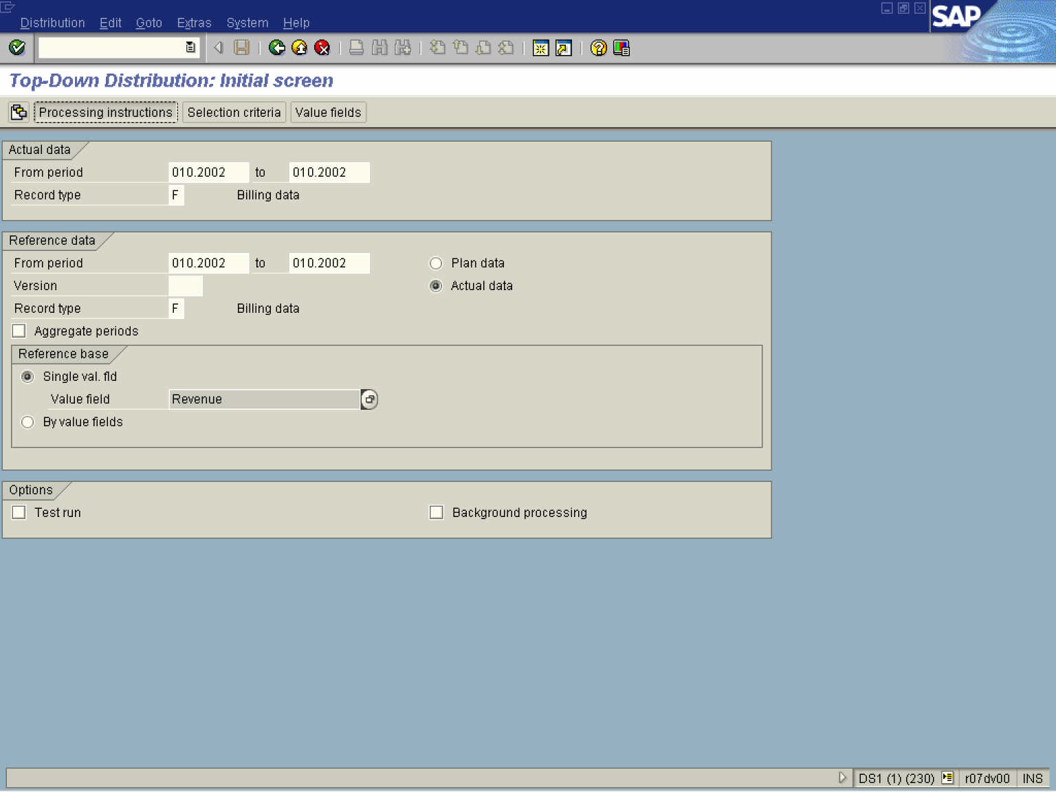

2. Update the following fields:

Field Name | Field Description | Values
From period | Beginning period of actual values to be distributed | Example: 10.2002
To | The last period of actual values to be distributed | Example: 10.2002
Record type | Type of business transaction the data transferred to CO-PA comes from. | Example: F
From period | Beginning period of reference data. | Example: 10.2002
To | The last period of reference data. | Example: 10.2002
Record type | Type of business transaction the data transferred to CO-PA comes from. | Example: F

3. Click the Actual data radio button.

4. Click the Test run checkbox to deselect.
5. Click the Processing instructions button.

Top-Down Distribution: Processing instructions

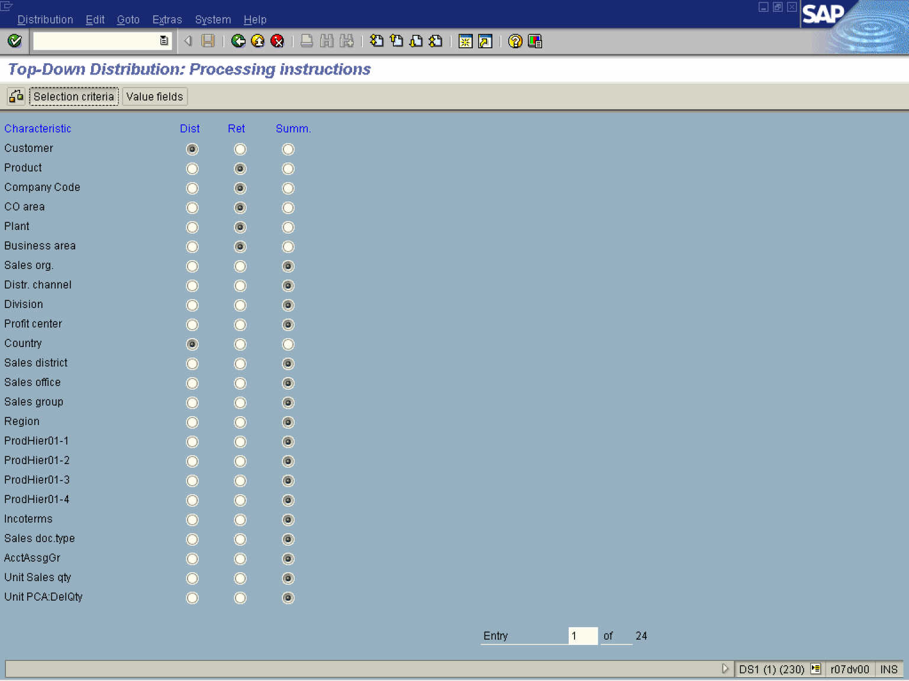

Note: Set the radio button for characteristics that you want to distribute in “Dist” column.

6. Click the Customer radio button.

7. Click the Country radio button.
8. Click the Selection criteria button.

Top-Down Distribution: Selection criteria

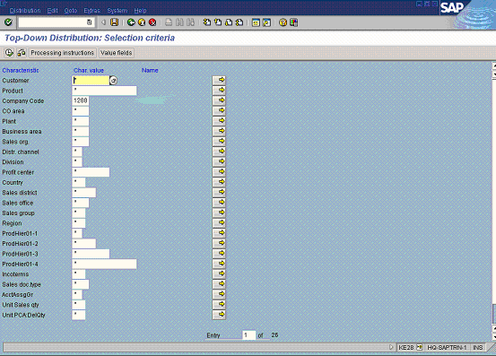

Note: Select the characteristic values that you want to distribute.

9. Update the following fields:

Field Name | Field Description | Values
Company Code | Code identifying the company. | Example: 1200

10. Click the Value fields button.

Top-Down Distribution: Value fields

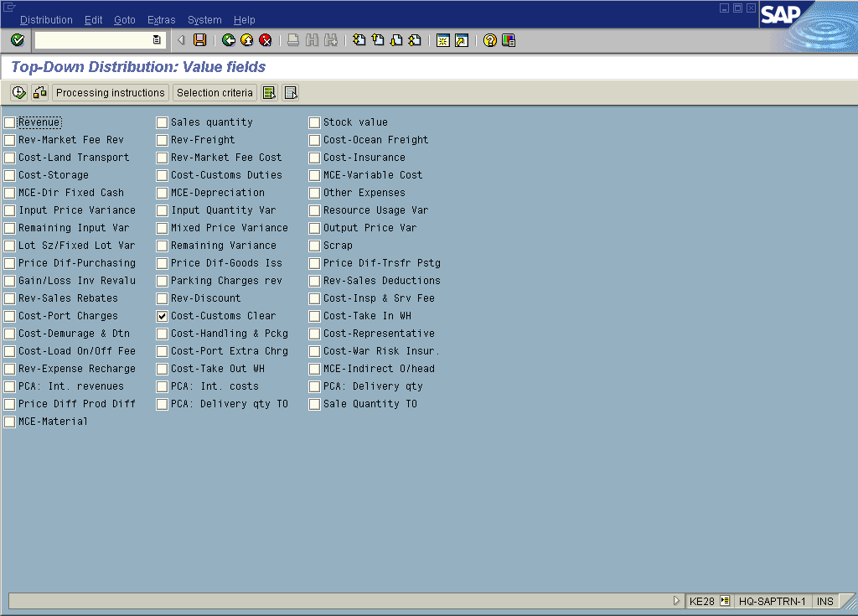

11. Click the Deselect all button.
Note: Select the Value fields that are to be distributed.

12. Click the Cost-Customs Clear checkbox.

Top-Down Distribution: Value fields

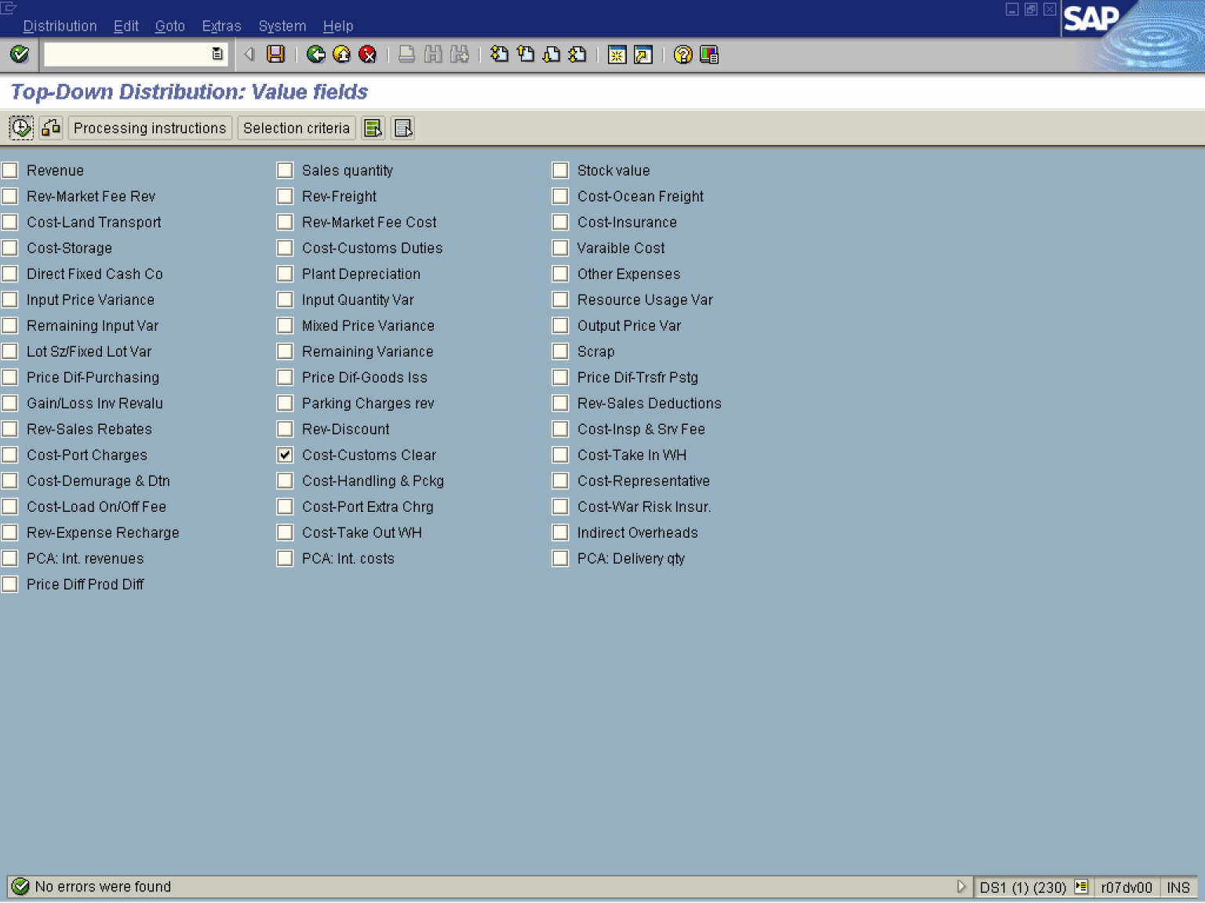

13. Click the Check button to check that there are no errors in the set-up of the top distribution.

14. Click the Execute button.

Top-Down Distribution: Log

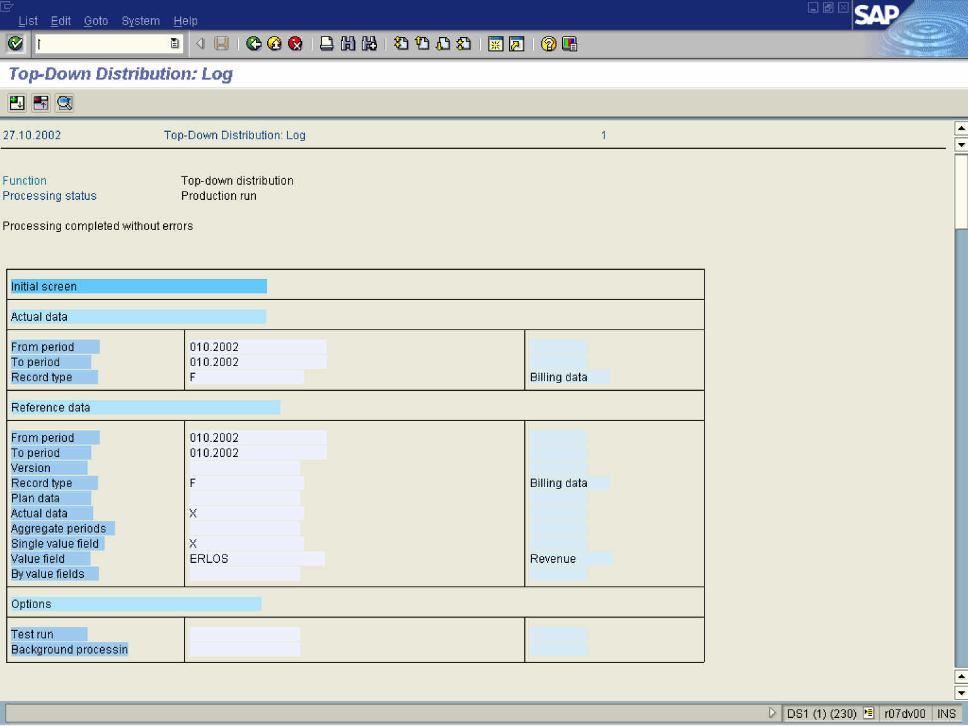

15. Click the Back button.

Top-Down Distribution: Initial screen

16. Click the Back button to go back to SAP Easy Access screen.

